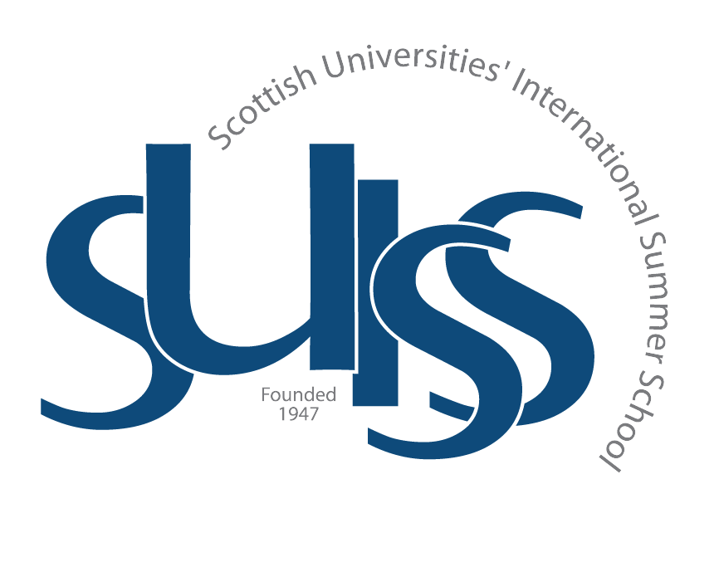
TEXT AND CONTEXT:
BRITISH AND IRISH LITERATURE
FROM 1900 TO THE PRESENT;
CREATIVE WRITING;
CONTEMPORARY THEATRE AND PERFORMANCE

DAILY PROGRAMME (10th July – 18th August 2017)
7.30 - 9.00 am Breakfast Pollock Halls
9.30 am Lectures/ Seminars George Square
10.45 - 11.15 am Coffee The Library Café
11.15 am Seminars/ Workshops George Square
1.15 pm Lunch The Library Café
(July)
6.00 - 7.30 pm Dinner Pollock Halls
(August)
4.30 - 8.00 pm Dinner Pollock Halls
8.00 pm Evening Events Grant House Common Rm.
(Unless otherwise stated)
Please make your own lunch arrangements on Saturdays and Sundays.

DEAN
Greg Walker, PhD, University of Edinburgh
Regius Professor of Rhetoric and English Literature
ASSOCIATE DEANS
Robert Irvine, PhD Vassiliki Kolocotroni, PhD
English Literature English Literature
University of Edinburgh University of Glasgow
ADMINISTRATIVE MANAGER
Lauren Pope, University of Edinburgh
Rhiannon da Cunha (maternity cover)
DIRECTORS
Hannah Tweed, PhD, University of Glasgow
Calum Rodger, PhD, University of Glasgow
TUTORS

Modernism
James Leveque, PhD, University of Edinburgh
Patrick Errington, University of St Andrews

Scottish Literature
Jim Benstead, University of Edinburgh
Alexandra Campbell, University of Glasgow
Contemporary Literature
Eleanore Widger, University of Dundee
Jessica Orr, University of St Andrews

Creative Writing
Defne Çizakça, PhD, University of Glasgow
Katy Hastie, University of Glasgow Nicky Melville, University of Glasgow
Theatre and Performance
Deryl Davis, University of Glasgow
Tim Jeeves, University of Lancaster

WEEK ONE: MODERNISM
Monday 10th July
8.00 pm | Welcome Reception  Grant House Common Rm.
Tuesday 11th July
9.30 am  2.00 pm  4.00 pm | Introduction to Imagist Poetry  Dr Andrew Frayn  Edinburgh Napier University  Library Tour  Arthur’s Seat Hike
Wednesday 12th July
9.30  2.30 pm  5.00 pm | Ford Madox Ford’s The Good Soldier  Dr Sarah Haslam  Open University  Mansfield Traquair Visit  Credit Information Seminar  Grant House Common Room
Thursday 13th July
9.30 am  8.00 pm | ‘A great gap between gallous story and dirty deed’: J.M Synge’s The Playboy of the Western World  Dr David Wheatley  University of Aberdeen  Cinepoems Showcase + Film poem Contest
Friday 14th July
9.30 am  8.00 pm | Katherine Mansfield and the Modernist Short Story  Dr Tara Thomson  Edinburgh Napier University  Ceilidh  St Trinneans & Nelson Rooms,  St Leonards Hall

WEEK TWO: MODERNISM
Monday 17th July
9.30 am  2.00 pm  3.00pm  8.00pm | James Joyce, A Portrait of the Artist as a Young Man  Dr Matthew Creasy  University of Glasgow  Postgraduate Information Seminar  Hugh Robson Lecture Theatre  Scottish Poetry Library Visit  Cinepoems Challenge Award Ceremony
Tuesday 18th July
9.30 am  2.30 pm | Virginia Woolf’s Mrs Dalloway  Dr Bryony Randall  The University of Glasgow  International Research Symposium  1.20 Dugald Stewart Building
Wednesday 19th July
9.30 am  2.30 pm | T.S. Eliot’s The Waste Land  Professor Robert Crawford  The University of St Andrews  Visit to Ian Hamilton Finlay’s Little Sparta
Thursday 20th July
9.30 am  8.00 pm | Liminal Women in Jean Rhys’s Good Morning, Midnight  Professor Emeritus Angela Smith  University of Stirling  Poetry Reading: Claire Askew & Russell Jones
Friday 21st July
9.30 am  8.00 pm | Alternative Modernisms: Christopher Isherwood, Berlin and ‘fatal readability’  Dr Rebecca Stewart  Bath Spa University  Farewell Party

WEEK THREE: SCOTTISH LITERATURE
Monday 24th July
8.00 pm | Welcome Reception  Grant House Common Room
Tuesday 25th July
9.30 am  2.00 pm  3.00 pm  4.00 pm | Hugh MacDiarmid and the Scottish Renaissance  Professor Alan Riach  The University of Glasgow  Library Tour  Credit Information Session  Grant House Common Room  Arthur’s Seat Poetic Expedition
Wednesday 26th July
9.30 am  8.00 pm | Lewis Grassic Gibbon’s Sunset Song  Professor Alison Lumsden  The University of Aberdeen  SUISS 70th Anniversary Reception  Playfair Library
Thursday 27th July
9.30 am  8.00 pm | The Imitation of Life: Muriel Spark’s The Prime of Miss Jean Brodie  Dr David Goldie  The University of Strathclyde  Janice Galloway Reading
Friday 28th July
9.30 am | Burke’s Black Watch and McGrath’s The Cheviot, the Stag and the Black, Black Oil  Dr Robert Irvine  The University of Edinburgh  LONG WEEKEND. TRAVEL, ENJOY!

WEEK FOUR: SCOTTISH LITERATURE
Monday 31st July
9.30 am  2.00 pm  3.00 pm | Edwin Morgan and Liz Lochhead  Dr Calum Rodger  The University of Glasgow  Postgraduate Study Information Seminar  Hugh Robson Lecture Theatre  National Library of Scotland Visit
Tuesday 1st August
9.30 am  2.00 pm | James Robertson’s The Last Testament of Gideon Mack  Dr Linda Tym  Southern Adventist University  Scottish Parliament Visit
Wednesday 2nd August
9.30 am  TBC  8.00 pm | Other Stories: The Short Fiction of A.L. Kennedy, Janice Galloway, and Ali Smith  Dr Tim Baker  The University of Aberdeen  Saltire Scholars’ Seminar  Creative Writing Open Mic Night
Thursday 3rd August
9.30 am  8.00 pm | Alasdair Gray’s Poor Things  Dr Michael Shaw  The University of Glasgow  James Robertson Reading
Friday 4th August
9.30 am  8.00 pm | David Greig’s The Strange Undoing of Prudencia Hart  Professor Penny Fielding  The University of Edinburgh  Farewell Party & Ceilidh, Prestonfield Room

WEEK FIVE: CONTEMPORARY LITERATURE
Monday 7th August
8.00 pm | Welcome Reception  Grant House Common Room
Tuesday 8th August
9.30 am  2.00 pm  4.00 pm | David Greig’s Europe  Dr Julia Boll  Universität Konstanz  Library Tour  Arthur’s Seat Hike
Wednesday 9th August
9.30 am  3.00 pm | Ideas are Bullet-Proof: Form and Politics in Alan Moore’s and David Lloyd’s V for Vendetta  Dr Chris Murray  University of Dundee  Credit Information Seminar  Grant House Common Room  FREE EVENING – FESTIVAL TIME!
Thursday 10th August
9.30 am  2.30 pm  8.00 pm | Zadie Smith’s White Teeth  Dr Michelle Keown  The University of Edinburgh  Translation Workshop with Viktoriia Ivanenko and Piotr Szymczak, Hugh Robson Lecture Theatre  Funded by Creative Scotland  Sinead Morrisey Reading
Friday 11th August
9.30 am  7.30 pm | Sinead Morrisey and Leontia Flynn  Dr Gail McConnell  Queen’s University, Belfast  Rhinoceros  Edinburgh International Festival, The Lyceum

WEEK SIX: CONTEMPORARY LITERATURE
Monday 14th August
9.30 am  2.00 pm  3.00 pm | Martin McDonagh’s The Cripple Of Inishmaan  Dr Maria Dick  The University of Glasgow  Postgraduate Information Seminar  Visit to…
Tuesday 15th August
9.30 am  TBC | Jeanette Winterson’s Written on the Body  Dr Simon Malpas  The University of Edinburgh  Loud Poets  Scottish Storytelling Centre
Wednesday 16th August
9.30 am | Caryl Phillips’ The Nature of Blood  Dr Anna McFarlane  The University of Glasgow  FREE EVENING – FESTIVAL TIME!
Thursday 17th August
9.30 am  8.00 pm | Ali Smith’s Autumn  Dr Churnjeet Mahn  The University of Strathclyde  David Greig Reading
Friday 18th August
9.30 am  8.00 pm | China Miéville’s Short Stories  Dr Elsa Bouet  Edinburgh Napier University  Farewell Party

WEEK ONE: CREATIVE WRITING
Monday 10th July
8.00 pm | Welcome Reception  Grant House Common Room
Tuesday 11th July
9.30 am  (Lecture)  2.00 pm  3.00 pm  4.00 pm | Introduction to Imagist Poetry  Dr Andrew Frayn  Edinburgh Napier University  Library Tour  Credit Information Seminar  Grant House Common Room  Arthur’s Seat Poetic Expedition
Wednesday 12th July
11.15 am  2.30 pm | Seminar (2hr)  24 Buccleuch Place (1.2, 1.3, 1.4)  Mansfield Traquair Visit
Thursday 13th July
11.15 am  2.00 pm  8.00 pm | Seminar (2hr)  24 Buccleuch Place (1.2, 1.3, 1.4)  Writing Half Day  Cinepoems Showcase + Film poem Contest
Friday 14th July
9.30 am  (Lecture)  11.15 am  8.00 pm | Katherine Mansfield and the Modernist Short Story  Dr Tara Thomson  Edinburgh Napier University  Masterclass with Zoe Strachan  ‘Looking for the devil in the detail’  Fiction Masterclass w/ Zoe Strachan  G.06, 50 George Square  Ceilidh  St Trinneans & Nelson Rooms,  St Leonards Hall

WEEK TWO: CREATIVE WRITING
Monday 17th July
10.15 am  2.00 pm  3.00 pm  8.00pm | Seminar (3hr)  24 Buccleuch Place (1.2, 1.3, 1.4)  Postgraduate Studies Information Seminar  Hugh Robson Lecture Theatre  Scottish Poetry Library Visit  Cinepoem Challenge Screening
Tuesday 18th July
10.15 am  2.00 pm | Seminar (3hr)  24 Buccleuch Place (1.2, 1.3, 1.4)  Writing Half Day
Wednesday 19th July
9.30 am  (Lecture)  2.30 pm | T.S. Eliot’s The Waste Land  Professor Robert Crawford  The University of St Andrews  Visit to Ian Hamilton Finlay’s Little Sparta
Thursday 20th July
9.30 am  (Lecture)  11.15 am  8.00 pm | Liminal Women in Jean Rhys’s Good Morning, Midnight  Professor Emeritus Angela Smith  University of Stirling  Hybrid Forms: Mixing and Collage Workshop  Poetry Masterclass with Colin Herd  G.06, 50 George Square  Poetry Reading: Claire Askew & Russell Jones
Friday 21st July
10.15 am  8.00 pm | Seminar (3hr)  24 Buccleuch Place (1.2, 1.3, 1.4)  Modernism Farewell Party  Grant House Common Room

WEEK THREE: CREATIVE WRITING
Monday 24th July
9.30 am  (Lecture)  11.15 am | Independent Publishing Lecture  Jenny Brown, Jenny Brown Associates  Writing Half Day
Tuesday 25th July
10.15 am  4.00 pm | Seminar (3hr)  24 Buccleuch Place (1.2, 1.3, 1.4)  Arthur’s Seat Poetic Expedition
Wednesday 26th July
11.15 am  8.00 pm | Masterclass with Rachel McCrum  G.06, 50 George Square  SUISS 70th Anniversary Reception  Playfair Library
Thursday 27th July
10.15 am  2.00 pm  7.00 pm | Seminar (3hr)  24 Buccleuch Place (1.2, 1.3, 1.4)  Writing Half Day  Janice Galloway Reading
Friday 28th July
9.30 am  (Lecture) | Burke’s Black Watch and McGrath’s The Cheviot, the Stag and the Black, Black Oil  Dr Robert Irvine  The University of Edinburgh  LONG WEEKEND. TRAVEL, ENJOY!

WEEK FOUR: CREATIVE WRITING
Monday 31st July
9.30 am  (Lecture)  11.15 am  3.00 pm | Edwin Morgan and Liz Lochhead  Dr Calum Rodger  The University of Glasgow  Graphic Novels and Visual Storytelling  Masterclass with Metaphrog  G.06 50 George Square  National Library of Scotland Visit
Tuesday 1st August
10.15 am  2.00 pm | Seminar (3hr)  24 Buccleuch Place (1.2, 1.3, 1.4)  Scottish Parliament Visit
Wednesday 2nd August
9.30am  (Lecture)  11.15 am  8.00 pm | Other Stories: The Short Fiction of A.L. Kennedy, Janice Galloway, and Ali Smith  Dr Tim Baker  The University of Aberdeen  Builder of Worlds:  Sci-fi Masterclass with Russell Jones  Creative Writing Open Mic Night
Thursday 3rd August
10.15 am  8.00 pm | Seminar (3hr)  24 Buccleuch Place (1.2, 1.3, 1.4)  James Robertson Reading
Friday 4th August
10.15 am  8.00 pm | Seminar (3hr)  24 Buccleuch Place (1.2, 1.3, 1.4)  Ceilidh and Farewell Party, Prestonfield Room

WEEK FIVE: THEATRE & PERFORMANCE

Monday 7th August
8.00 pm | Welcome Reception  Grant House Common Room
Tuesday 8th August
9.30 am  (Lecture)  11.15 am  2.00 pm  4.00 pm | David Greig’s Europe  Dr Julia Boll  Universität Konstanz  Seminar  Library Tour  Arthur’s Seat Dramatic Expedition
Wednesday 9th August
9.30  (Lecture)  11.15 am  2.00 pm | Ideas are Bullet-Proof: Form and Politics in Alan Moore’s and David Lloyd’s V for Vendetta  Dr Chris Murray  University of Dundee  Seminar  Credit Information Session  21 Buccleuch Place  FREE EVENING – FESTIVAL TIME!
Thursday 10th August
9.30 am  2.30 pm  8.00 pm | Seminar  Translation Workshop with Viktoriia Ivanenko and Piotr Szymczak, Hugh Robson Lecture Theatre, Funded by Creative Scotland  Sinead Morrissey Reading
Friday 11th August
9.30 am  (Workshop)  1.30 pm  7.30 pm | Workshop: Fifteen Rules of Acting  Ali de Souza, Royal Conservatoire of Scotland  G.04, 50 George Square  Seminar  Rhinoceros  Edinburgh International Festival, The Lyceum
WEEK SIX: THEATRE & PERFORMANCE

Monday 14th August
9.30 am  (Lecture)  11.15 am  2.30 pm  7.30 pm | Martin McDonagh’s The Cripple of Inishmaan  Dr Maria Dick  The University of Glasgow  Seminar  Panel discussion at Traverse Theatre  Performance TBC  Traverse Theatre
Tuesday 15th August
9.30 am  2.00 pm  4.00 pm  7.30 pm | Seminar  Gender and Performance Workshop  with Olga Taxidou  G.04, 50 George Square  Postgraduate Information Session  Performance TBC  Traverse Theatre
Wednesday 16th August
9.30 am  2.00 pm | Seminar  Workshop with the Playwrights’ Studio  G.04, 50 George Square  FREE EVENING – FESTIVAL TIME!
Thursday 17th August
9.30 am  2.00 pm  8.00 pm | Seminar  Workshop with the Playwrights’ Studio  G.04, 50 George Square  David Greig Reading
Friday 18th August
9.30 am  2.00 pm  8.00 pm | Seminar  Workshop with Plutot la Vie  G.04, 50 George Square  Farewell Party

